Black History Month Market

Information Pack

Bramlands Square, Clapham Junction

Wandsworth Council is hosting a Black History Month celebration featuring a vibrant market of Afro-Caribbean fashion, beauty, lifestyle, art and food. Black-owned businesses, local traders, makers and food vendors are invited to showcase their products in the heart of Clapham Junction, just across the road from the station. The market will take place at Bramlands Square, SW11 2NR, on Saturday 17 October from 12pm to 5pm, alongside workshops and performances. Submit an expression of interest by 4 October using this online form.
Contents
Location 1
Site Plan 2
Frequently Asked Questions 2
Stallholder Terms and Conditions 4

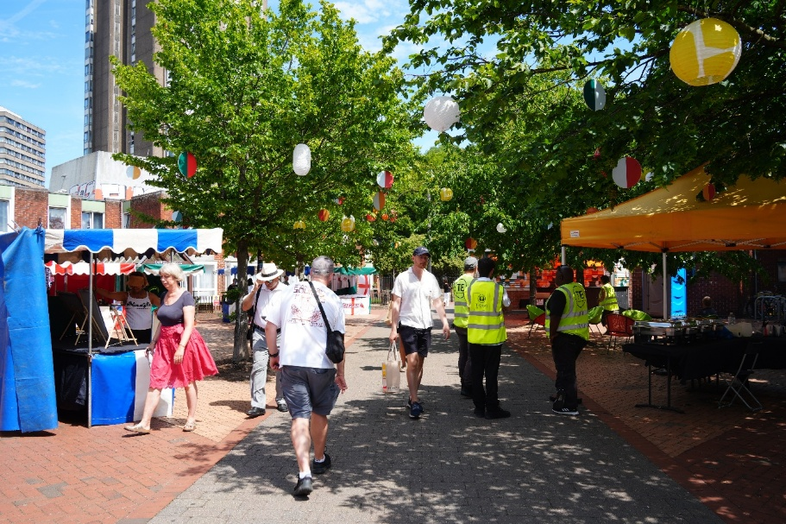

Location
Bramlands Square, SW11 2NR. Between Dawes House and Grant Road. Just opposite Clapham Junction Station.
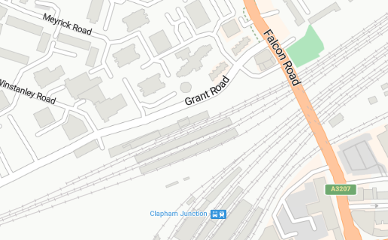

Site Plan

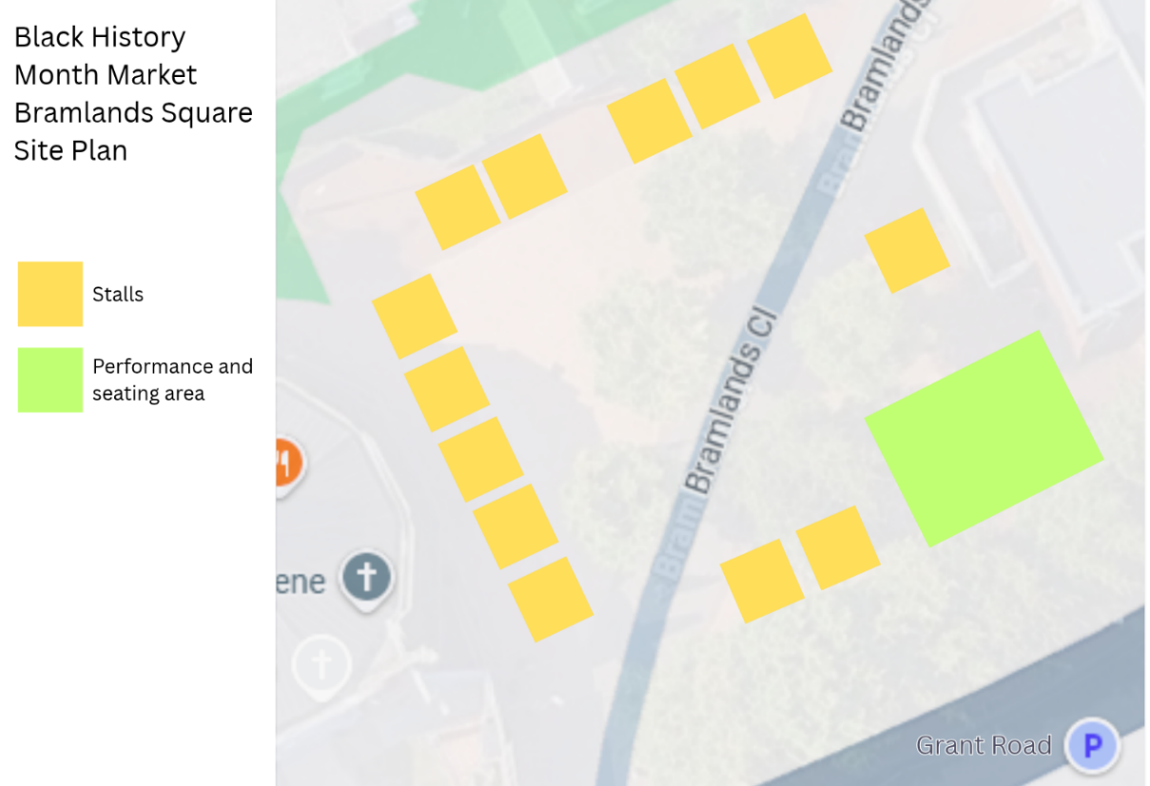

Frequently Asked Questions
- What is this all about?
As part of the Council’s Black History Month programme we will be showcasing a select range of African-Caribbean owned businesses based in the borough.
- Where will the market be?
Bramlands Square, SW11 2NR. Between Dawes House and Grant Road.
- When?
Saturday 17 October 2026, 12pm - 5pm
- Set up and set down time:
Set up is at 10.30am. Set down is from 5pm.
- What are the requirements?
You need to be a registered business/SME owner of an African-Caribbean heritage, whose business is located and trading in the borough of Wandsworth.
- Can I just pop up and trade?
You will have to register your interest with us, by completing the Expression of Interest form no later than 30 September before you may get assigned a place.
- Will I be guaranteed get a place/stall?
The spot has very high footfall and so we expect this opportunity to be competitive, thus we cannot guarantee that all who request to participate will get a stall.
- Are there any costs involved?
The stall fee is £35. This will be collected prior to the event to secure your spot.
- Parking
Paid parking is available on surrounding roads.
- Am I insured trading there?
Stall holders are required to have their own Public Liability Insurance. We will need to see proof of this prior to the event.
- When will I know if I have a place?
Once the deadline has passed; we will review all Expressions of Interest and make a decision.
- What can I do if I have a different question?
Other questions can be emailed to us at Open4business@richmondandwandsworth.gov.uk

Stallholder Terms and Conditions
Stallholder Requirements
To participate, stallholders must:
1. Read and agree to the Terms and Conditions below.
2. Complete and submit the Expression of Interest Form and email Open4business@richmondandwandsworth.gov.uk with images of your product/previous stall setups.
3. Once selected, provide a copy of their Public Liability Insurance and pay the £35 stallholder fee.
TERMS & CONDITIONS
Public Liability Insurance:
All stallholders must hold valid Public Liability Insurance of a minimum of £5M. Stallholders are responsible for ensuring that Wandsworth Council is always provided with an up-to-date certificate of insurance. This includes providing a renewed certificate upon expiry or replacement of their policy.
Health & Safety Compliance:
All equipment, products, and activities must comply with current Health & Safety legislation. Electrical items must be safety-tested and have a PAT certificate, and any gas equipment must hold a valid safety certificate. All stallholders must ensure their setup is safe and does not pose any risk to staff, visitors, or other exhibitors.
Licences & Permits:
Stallholders are responsible for obtaining and displaying any licences, certificates, or permits required for their type of trade.
Food Safety & Hygiene:
All food and drink vendors must comply with current UK Food Safety and Hygiene Regulations. Proof of local authority registration and valid Food Hygiene Certificates may be required prior to an event.
Gazebos and Structures:
Gazebos will be provided. But, in the case where a stallholder has agreed in advance to bring their own gazebo, then it must be sturdy, suitable for all weather conditions, and securely anchored with a minimum of 12kg weight on each leg (front and back). Without the required weights, stallholders will not be permitted to trade.
Tables and Chairs:
1 table and 1 chair will be provided per stall. You will need to supply your own: tablecloth and decoration.
Electricity:
Electricty is limited and any electrical requirements must be agreed in advance. If electrical power is provided, it must only be used for approved appliances. Overloading the supply is prohibited. Stallholders must bring their own PAT tested extension leads.
Pitch Allocation & Layout:
Pitches are allocated at the discretion of Wandsworth Council. While requests for specific positions will be considered, they cannot be guaranteed. Layout changes may be made at any time for operational or safety reasons.
Payment:
Once selected, immediate payment of £35 is required to secure your pitch. If payment has not been received within 2 days, Wandsworth Council reserves the right to reassign or release your pitch.
Cancellation and Refund Policy
Any cancellations by the stallholder will not be eligible for a refund.
Set-Up and Take-Down Times:
Stallholders will be notified of set-up and breakdown times prior to the event. For health and safety reasons, these times must be strictly adhered to. All stallholders must remain on site until the end of the market.
Waste Management:
Pitches must be left clean and as originally found. All rubbish should be left in bin bags ready for Wandsworth Council to dispose of. We encourage stallholders to use reusable, compostable or recycled materials where possible and limit the use of single use plastic.
Photography & Promotion:
Stallholders consent to Wandsworth Council using photographs or video footage of their stall, products, or activities for promotional purposes in print, online, and social media.
Disclaimer
Wandsworth Council reserves the right, for reasons beyond its reasonable control, to alter the content, timing, or location of the event or its attractions at any time.
Wandsworth Council shall not be liable for any travel, accommodation, or other costs incurred due to cancellation or relocation resulting from circumstances beyond its control, including but not limited to flood, storm, fire, explosion, war, terrorism, strikes, lockouts, industrial action, pandemic, epidemic, or other widespread illness.

